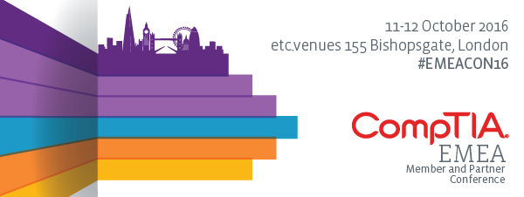

Helpful Links:
Event Homepage: www.comptia.org/emea
Registration: https://www.comptia.org/emea/register
Agenda: www.comptia.org/emea/agenda
Travel/Hotel: www.comptia.org/emea/register/hotel-travel
What is the EMEA Member & Partner Conference?
- CompTIA’s EMEA Member and Partner Conference (EMEACon) brings together leading IT solution providers, vendors, distributors, training companies, academies and content publishers to connect, collaborate and gain insight into the latest technologies and trends to help grow their businesses and the industry. Over 40% of attendees are at the Executive or Senior Management level.
- This two-day event features two session tracks – UK Channel and CompTIA Partners – which is followed by a networking dinner for all conference delegates. EMEACon is open to everyone working within the tech channel; including CompTIA Premier Members, Registered Users, non-members and Partners.
- Channel delegates benefit from:
  - Brainstorming with industry executives, educators and thought-leaders under one roof to discuss the common challenges facing our industry and strategise collaboratively to help shape the future of the IT industry.
  - Gaining insight into the latest industry developments and market research trends.
  - Participating in training courses and Quick Start Sessions.

EMEACon Short Copy:
CompTIA’s 2016 EMEA Member and Partner Conference is taking place on the 11-12th October at etc.venues 155 Bishopsgate in London.
EMEACon brings together leading IT solution providers, vendors, distributors, training companies, academies and content publishers to connect, collaborate and gain insight into the latest technologies and trends to help grow their businesses and the IT industry.
The Conference is open to CompTIA Premier Members, Registered Users, non-members and Partners. Register today!

Key Speaking Points:
- The CompTIA EMEA Member & Partner Conference (EMEACon) is one of the leading events to gain insight and partnership opportunities for the IT channel.
- The EMEA Conference helps organisation find new ways to work and improve business through education, collaboration and partnership.
- Attendees not only get value from the expert speakers and networking but also walk away with tools and resources to help build better businesses.
- We have found that Solution Providers get the most out of the conference if two or more staff attend – ensuring all of the great stuff gets captured.
- You will have the chance to meet and network with more than 300+ senior executives from the industry, find new opportunities for partnership and share insight with peers who understand your challenges.
- CompTIA Premier Members receive unlimited complimentary registrations.
- 9 out of 10 attendees say attending the EMEA Conference has had a positive effect on their business.
- There is no sales agenda with this – only our drive is to help support and guide IT businesses and the channel to be more successful.
- Most other industry events, do not provide the environment for collaboration or networking quite like EMEACon.

Sample Social Media Posts:
- Will look forward to seeing you at the @CompTIA #EMEACon16, the premier training and partnering event for the IT channel. www.comptia.org/emea
- Travel is booked, we’re set for #EMEACon16 on 11-12 October in London. Join us with @CompTIA! www.comptia.org/emea
- Create new partnerships and check out what’s hot in the #Tech channel at #EMEACon16. www.comptia.org/emea
- Form new partnerships and check out the hottest cutting edge technology at the @CompTIA Technology Vendor Fair #EMEACon16.
- The IT Channel will be at @CompTIA’s #EMEACon16. Will you? www.comptia.org/emea
- No sales pitches from the podium –@CompTIA’s EMEACon is a vendor-neutral IT event #EMEACon16.
- 300+ attendees – the best ITC channel networking event of the year #EMEACon16 from #CompTIA.
- Get the skills to break into new markets at @CompTIA’s #EMEACon16
- Be our VIP guest @CompTIA #EMEACon16 (£200 value), the IT destination hot spot!

