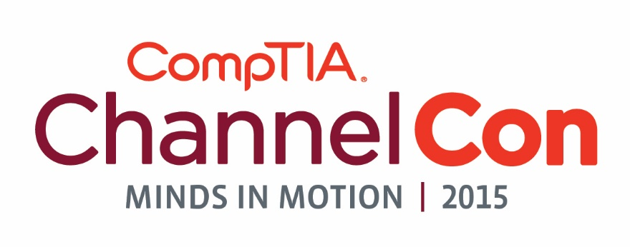
_____________________________________________________________________________________
Helpful Links
Event Homepage: www.comptia.org/channelcon
Registration Link: https://www.comptia.org/channelcon/registration/registration-form
Agenda: https://www.comptia.org/channelcon/agenda/daily-agenda
Exhibitor List: https://www.comptia.org/channelcon/exhibitors
Travel/Hotel: https://www.comptia.org/channelcon/travel-hotel
Facebook Event: https://www.facebook.com/events/1436663653295132/
_____________________________________________________________________________________
What is CompTIA ChannelCon?
ChannelCon, the premier training and partnering event for the IT channel, is coming to Chicago, August 3-5 at the Hilton Chicago on Michigan Avenue.
ChannelCon features the best cross-section of solution providers, vendors, distributors and media. Learn from each other and hear from the industry’s greatest thought-leaders.
ChannelCon features high-level executive panel discussions as well as intensive executive certificate training courses on the subjects most important to your business today.
This is the big-tent event for the IT channel – the best cross-section of solution providers, vendors, distributors and media – giving attendees the chance to learn from each other and the industry’s greatest thought-leaders.
_____________________________________________________________________________________
ChannelCon Short Copy
SOLUTION PROVIDERS Fast-track your way to success by attending channel training courses, sourcing new end-to-end solutions, networking with your peers and collaborating with industry leaders. You can earn certificates and gather tools and resources to immediately implement into daily practice. Solution providers will leave ChannelCon with the know-how and connections necessary to increase revenue and win more business. As a valued partner, you can register today at no cost using promo code (enter promo code here).
_____________________________________________________________________________________
Key Speaking Points
CompTIA ChannelCon, is the premier training and partnering event for the IT Channel.
Connect to the industry with channel training and education, collaboration and partnering.
CompTIA ChanenlCon is the only vendor neutral, non-hosted channel event of its size allowing you the freedom to pick the sessions you need to accelerate your business.
Walk away with tools and resources you can immediately implement into your business.
Send at least two staff members to get the most out of the ChannelCon .
CompTIA Premier Members receive unlimited free registrations.
We hope you find that Chicago feels like home during ChannelCon 2015. The convention will be held at the Hilton Chicago on Michigan Avenue, and we’ve negotiated a special ChannelCon rate of $159 if you book by Monday, July 13, 2015. Book now.
Communities drive CompTIA. Help drive industry-wide programming by participating in our various member communities, which advance specific technologies, vertical markets or business segments vital to the IT industry. Community Day is Monday, August 4.
_____________________________________________________________________________________
Sample Social Media Posts
Will we see you at @CompTIA’s #ChannelCon15, the premier training and networking event for the IT channel? www.comptia.org/channelcon
Travel is booked, we’re set for #ChannelCon15 Aug. 3-5 in Chicago with @CompTIA. Join me! www.comptia.org/channelcon
Break into new business avenues at #ChannelCon15: www.comptia.org/channelcon
Form new partnerships and check out the hottest cutting edge technology at the Technology Vendor Fair #ChannelCon15
The IT Channel will be at #ChannelCon15 – will you? www.comptia.org/channelcon
There’s nothing like it for IT channel professionals: #ChannelCon15 is coming to Chicago Aug. 3-5: www.comptia.org/channelcon
No sales pitches from the podium – #ChannelCon15 is the largest vendor neutral IT event www.comptia.org/channelcon
_____________________________________________________________________________________
ChannelCon ROI
65% of the attendee base reports they made a minimum of five new business relationships at ChannelCon.
ChannelCon Positively Impacts 90% of Attendees
“Channelcon’s a great event, and it’s one of the things that I know I look forward to, and so do a lot of other people who are members.” —ChannelCon 2014 Attendee
Use the ChannelCon App — last year, 60% of exhibitors found it valuable for making appointments and new business connections.
ChannelCon is covered annually by all of the major channel media outlets, from Business Solutions and MSPmentor to Talkin’ Cloud and The VAR Guy.
_____________________________________________________________________________________
Five Reasons To Attend
1. EDUCATION Earn business credentials and executive certificates on-site.
2. CONNECTIONS Collaborate with the IT channel’s most expansive cross-section of industry leaders.
3. INSPIRATION Hear from engaging conference speakers on market trends and new business opportunities.
4. PROSPECTS Participate in peer-to-peer learning and networking and develop new partnerships.
5. PLANNING Implement ideas from our Sales Tool Kit or from your free ITLA consultation as soon as you’re back in the office.

