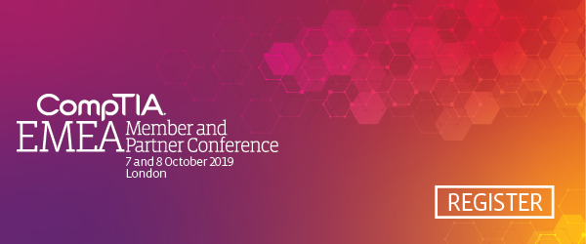

Helpful Links:
Event Homepage: www.comptia.org/emea
Registration: www.comptia.org/emea/register
Agenda: www.comptia.org/emea/agenda
Travel/Hotel: www.comptia.org/emea/hotel-travel
What is the EMEA Member & Partner Conference?
- Any company that builds, sells, distributes or influences the adoption of technology solutions can’t afford to miss this event. The EMEA Conference is your connection to gain access to unbiased industry insight and emerging technology trends. Don’t miss your chance to establish the valuable connections and partnerships that can help transform your business now.
- Attendees benefit from:
  - Networking: Get face-time with high-level executives from North Cape to South Africa and everywhere in between to share strategies and best practices.
  - Action Items: Get informed and inspired by plans and concepts that you can directly apply to your business to achieve a bottom-line impact.
  - Fast Learning: Training courses and quick start sessions to improve ICT skillsets. Gain valuable insight into emerging tech trends and exclusive market research.
EMEA Short Copy:
CompTIA’s 2019 EMEA Member and Partner Conference is set for 7-8 October at Park Plaza Westminster Bridge Hotel in London. Technology today is all about making the impossible possible, turning ambitious ideas into reality. Driven by emerging technologies such as AI, IoT, blockchain and cybersecurity, businesses are thinking bigger—and better. This year’s CompTIA EMEA Member and Partner Conference provides the valuable insights and analysis needed to start solving tomorrow’s business problems today, whether you’re in the business of technology ecosystem or training and teaching tech skills. Don’t miss this unique opportunity to learn about the latest trends, network with peers and industry executives, and start charting your course for future success. #EMEACon is open to CompTIA members, non-members and partners. Register today at no cost using promo code (enter your unique promo code here).

Key Speaking Points:
The EMEA Conference is your connection to gain access to unbiased industry insight and emerging technology trends.
The EMEA Conference will prepare you and your organisation with ways to better connect through education, collaboration and partnering.

You will walk away with tools and resources you can immediately implement to build a better business or transition into a new market.

Solution Provider organisations will optimise the EMEA experience if they send two or more staff to attend.

Attendees will participate in the UK Channel Community meeting and gain valuable tips and insights from their peers across the industry.
You’ll meet with more than 350+ senior executives from the industry, connect with new partners and reconnect with peers.

Sample Social Media Posts:
- Will we see you at the @CompTIA #EMEACon, the premier training and partnering event for the IT channel? www.comptia.org/emea
- Travel is booked, we’re set for #EMEACon 7-8 October in London. Join us with @CompTIA! www.comptia.org/emea
- Form new partnerships and check out the hottest cutting edge technology at the @CompTIA Technology Vendor Fair #EMEACon.
- Tech Organisations will be at @CompTIA’s #EMEACon. Will you? www.comptia.org/emea
- No sales pitches from the podium –@CompTIA’s EMEA Con is a vendor-neutral tech event #EMEACon.
- 350+ attendees – the best technology networking event of the year #EMEACon from #CompTIA.
- Break into new markets through intense Training at @CompTIA’s #EMEACon.

EMEA Conference ROI:
9 in 10 attendees are confident the EMEA Conference has a positive impact on their business.
92% of attendees report a positive experience at the conference.
9 in 10 attendees would recommend the UKCC meeting to their colleagues.

